2023 Children’s Club Guidelines

(Application Period) Dec 1, 2022 (Thurs) to Dec 28 (Wed)
※ Apply during this period even if you are only using the room during a long vacation.

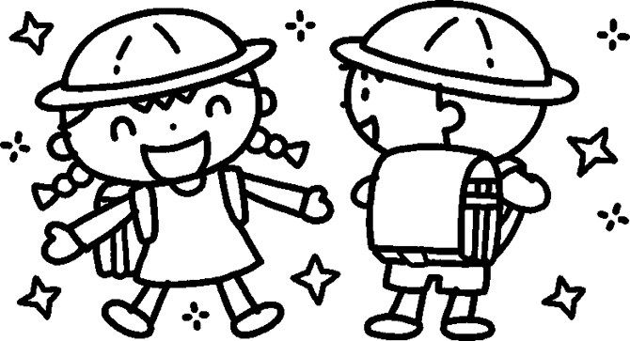

Children's Houses / Children's Centers offer after-school clubs for elementary school children in grades 1 to 6 from families with children who have to spend time alone after school, such as those where both parents work, etc.

School Age Childcare Information
■Target ・Children (1st-6th grade elementary school students) whose parents are away from home for work, etc.
・Children who require guidance for sound upbringing
※ Application may be denied based on the status of the application, non-payment, etc.
Usage | Hours
Weekdays | After school to 18:00
Saturdays and vacations (spring, summer, winter) | 8:00 to 18:00
■ Hours

※ To use the service outside of childcare hours due for unavoidable reasons, please contact us.
We can accommodate you only during the following hours:
Early morning | 7:30 to 8:00
Extended hours | 18:00 to 19:00

■Closed Sundays, national holidays, New Year’s (Dec 29 through Jan 3)
Obon (Aug 14, 15)
※Note that the centers are unable to respond to lost and found items outside of open hours.
Usage |  | Fees
Monthly (excluding August) (Mon-Sat)  Monthly (excluding August) (Mon-Fri) |  | 8,500 yen/month  7,000 yen/month
August (Mon-Sat)  August (Mon-Fri) |  | 12,000 yen  10,500 yen
Temporary Use  (under 10 days) | Weekdays (after school to 18:00) | 450 yen/use
 | Saturdays, vacations, substitute holidays | 600 yen/use
■ Fees

※ For early morning or extended hours, the following fees will be added.
Usage | Fees
7:30 to 8:00 (early morning) | 200 yen/use | (Mon-Sat) 3,500 yen/month  (Mon-Fri) 3,000 yen/month
18:00 to 18:30 (extended hours) | 200 yen/use | (Mon-Sat) 3,500 yen/month  (Mon-Fri) 3,000 yen/month
18:00 to 19:00 (extended hours) | 350 yen/use | (Mon-Sat) 4,500 yen/month  (Mon-Fri) 4,000 yen/month

■ Payment Generally, direct debit from a bank account is accepted.
※In the event of nonpayment of fees, you may be asked to leave the facility.
About Life at the Center
■ Daily routine: arrive → change clothes → snack → homework → play → clean up → go home
■ We provide time for homework, but we ask that you check it at home as well.

Caution
■ Be sure to have a parent or guardian pick up and drop off the child.
■ Be sure to contact the Children's Center in the following cases
・ If you will be absent (let us know if you will be absent from school as well)
・ If you will be late picking up your child
・ If the person picking up the child is different from the person applying
■ Do not bring toys, games, money, or other important items to the center.
■ To ensure an enjoyable time, we ask parents/guardians to tell their children to keep the following promises:
［Promises］
・ After leaving school, visit the center without making any detours.
・ Do not leave the center without permission.
・ Treat the center’s property with care. (You may be asked to pay for any intentional damage.)
・ Do not play rough with friends or use hurtful language.
※ We reserve the right to suspend or terminate acceptance of any student who behaves in a manner that disrupts the group life.

■ Decisions cannot be changed during the period of use unless there is a compelling reason to do so. If you wish to change your decision, please submit a notification by the end of the preceding month.
■ Please submit a cancellation notice when you will stop using the service due to relocation or other reasons.
Requests
■ Please write your name on all your belongings.
■ For hygiene purposes, please bring a handkerchief every day.
■ Have your child bring a change of clothes in a bag every day after school.
(You may bring the next day’s clothes when you pick up your child.)
■ On days when there is no school lunch, please bring a lunch box and water bottle.

Payment Method
■ Please use bank account transfer.
■ The date of debit will be the last day of the following month (or the following day if that day is a bank holiday).
■ Application forms for automatic payment are available at the Children's Center.

In case of typhoon/heavy rain/heavy snow/etc.
Generally, after-school children's clubs and childcare centers will be open as follows when elementary schools in the district are temporarily closed or when children are required to stay at home.
(The safety of the children is a priority when the school has determined that the situation poses a danger to their ability to get to and from school.)
１．Temporary school closure (all day) |  | Closed
２．When students stay at home only in the morning (including when students come to school from mid-morning) |  | Open (except in the morning)
３．Mid-day closures | Before lunchtime | Closed
 | After lunch is eaten | Open (children's clubs only)

※ Centers may not open when schools do not allow children to leave in groups, but instead requires them to wait at school until they are handed over to their parents.

【In case of heavy rain, storms, snow, or other warnings on Saturdays, vacations, or substitute holidays】
- If the center closes due to the situation, we will notify you by emergency mail.
- Even if the center opens, we may ask you to pick up your child early depending on the situation.

  - Emergency mails are sent from emc-echizen-shakyo@emc.fukui-nct.ac.jp
  - If you have an anti-spam filter on your cell phone or other device, you may not receive our e-mails.

≪Contact≫
＊〇〇 Children’s Center ℡ 〇〇-〇〇〇〇（12:30～18:00）
＊Echizen City Council of Social Welfare (Takefu Branch) ℡ 22-8500 (8:30～17:00)

